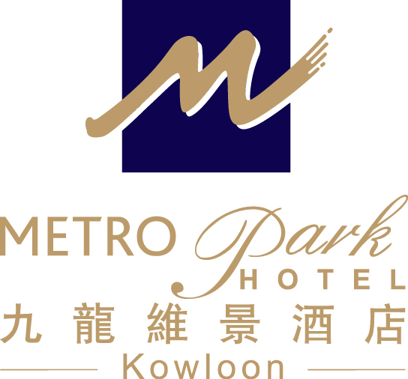
Inaugural International Conference on Open and Flexible Education
The Open University of Hong Kong (16 – 17 January 2014)

Accommodation Reservation Form
Metropark Hotel Kowloon
(15 – 18 January 2014)

Guest Name: Mr/Ms/Mrs/Prof./Dr. (First name) (Last name)

Contact: (Tel) (Fax) (Email)

Arrival Date: (DD/MM/YY) Departure Date: (DD/MM/YY)

Room category & Package: Superior Single/Double Room

1. Room only: HK$ 950 net per room per night
2. Room with 1 pax buffet breakfast: HK$1,030 net per room per night
3. Room with 2 pax buffet breakfast: HK$1,110 net per room per night

No. of Room(s)

Airport Shuttle: Airport→Hotel Hotel→Airport

* The rate is inclusive of 10% service charge and is subject to the hotel confirmation.
- One- way complimentary transfer (Airport / Hotel) by shuttle bus (upon arrival or departure). Round trip airport transfer will be offered for any stay of two consecutive nights or above. The shuttle bus departs Airport / Hotel on regular basis (please contact our Airport Representatives at Counter “B17” at the Airport’s Arrival Hall / Hotel Reception).
- Free in – room broadband Internet access (unlimited usage)
- Welcome fruit set-up and free local telephone calls
- Free use of fitness room facilities

- All bookings should be guaranteed by a credit card.

Booking Guaranteed By: Amex Visa Master Diners

Card holder: Card No. : Expiry Date:

Notes: 1. The special rate is only applicable to delegates of the above conference.
2. The deadline for making reservation is on or before 30 November 2013 and the accommodation is subject to availability.
3. All the expenses are on guest own account.
4. In case of ‘No show’ or ‘Late Cancellation’, a penalty charge which is equivalent to 1 night’s room rental will be levied.
5. Cancellation without penalty charge must be reported to Hotel at least 72 hours prior to the scheduled arrival date.

Date of Application: Signature:

For reservations, please contact -Metropark Hotel Kowloon, S & M Office
Ms. Anita Hung (Business Development Manager)
Tel：（852）21973431 Fax：（852）2760 3603

E-mail：abdm.hkkl@metroparkhotels.com

Metropark Hotel Kowloon 九龍維景酒店
Address : 75 Waterloo Road, Kowloon, Hong Kong 香港九龍窩打老道75號

