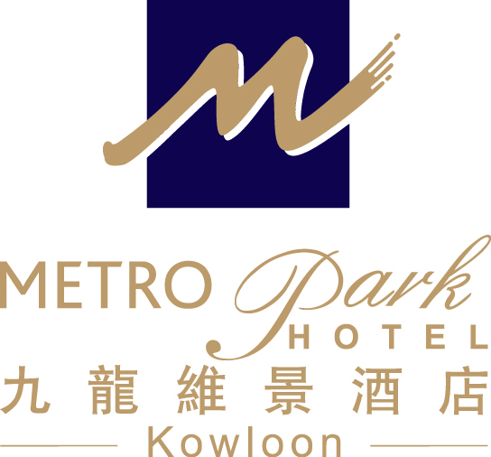
2015 International Conference on Open and Flexible Education (ICOFE 2015)
The Open University of Hong Kong (15 – 18 July 2015)
Accommodation Reservation Form - Metropark Hotel Kowloon

Guest Name: Mr/Ms/Mrs/Prof./Dr. (First name) (Last name)
Contact: (Tel) (Fax) (Email)
Arrival Date: (DD/MM/YY) Departure Date: (DD/MM/YY)

Room category & Package: Superior Single/Double Room
1. Room only: HK$ 880net per room per night
2. Room with 1 pax buffet breakfast: HK$970 net per room per night
3. Room with 2 pax buffet breakfast: HK$1060 net per room per night

No. of Room(s)

Airport Shuttle: Airport→Hotel Hotel→Airport
Advance booking is requested and kindly provide below information so as for us to reserve the seat.
Airport ----> Hotel: 07: 15 - 23: 00 hrs (Every 30 minutes)
Hotel ----> Airport: 05: 10 - 21: 10 hrs (Every 1 hour)
(Please contact our Airport Representatives at Counter “B17” at the Airport’s Arrival Hall / Hotel Reception)
- Passenger Name(s):
- No. of passenger(s):
- Arrival Date:
- Flight No. & Arrival Time:
Remarks:
² One Way complimentary transfer (Airport / Hotel) by shuttle bus (upon arrival or departure). Round trip
airport transfers will be offered for any stay of two consecutive nights or above. The shuttle bus departs Airport /
Hotel on regular basis, must be pre-booked at least 24 hours in advance.
² Cancellation needs to be reported to Hotel for at least 24 hours prior to the scheduled arrival date.

* The rate is inclusive of 10% service charge and is subject to the hotel confirmation.
- Free in – room Wi-Fi Services
- Welcome fruit set-up and free local telephone calls
- Free use of Hotel’s swimming pool and fitness room facilities
- All bookings should be guaranteed by a credit card.

Booking Guaranteed By: Amex Visa Master Diners
Card holder: Card No. : Expiry Date:
Notes: 1. The special rate is only applicable to delegates of the above conference.
2. The deadline for making reservation is on or before 30 June 2015 and the accommodation is subject to availability.
3. All the expenses are on guest own account.
4. In case of ‘No show’ or ‘Late Cancellation’, a penalty charge which is equivalent to 1 night’s room rental will be levied.
5. Cancellation without penalty charge must be reported to Hotel at least 72 hours prior to the scheduled arrival date.

Date of Application: Signature:
For reservations, please contact -Metropark Hotel Kowloon, S & M Office
Ms. Anita Hung (Business Development Manager)
Tel：（852）21973431 Fax：（852）2760 3603
E-mail：abdm.hkkl@metroparkhotels.com

Metropark Hotel Kowloon 九龍維景酒店
Address : 75 Waterloo Road, Kowloon, Hong Kong 香港九龍窩打老道75號

