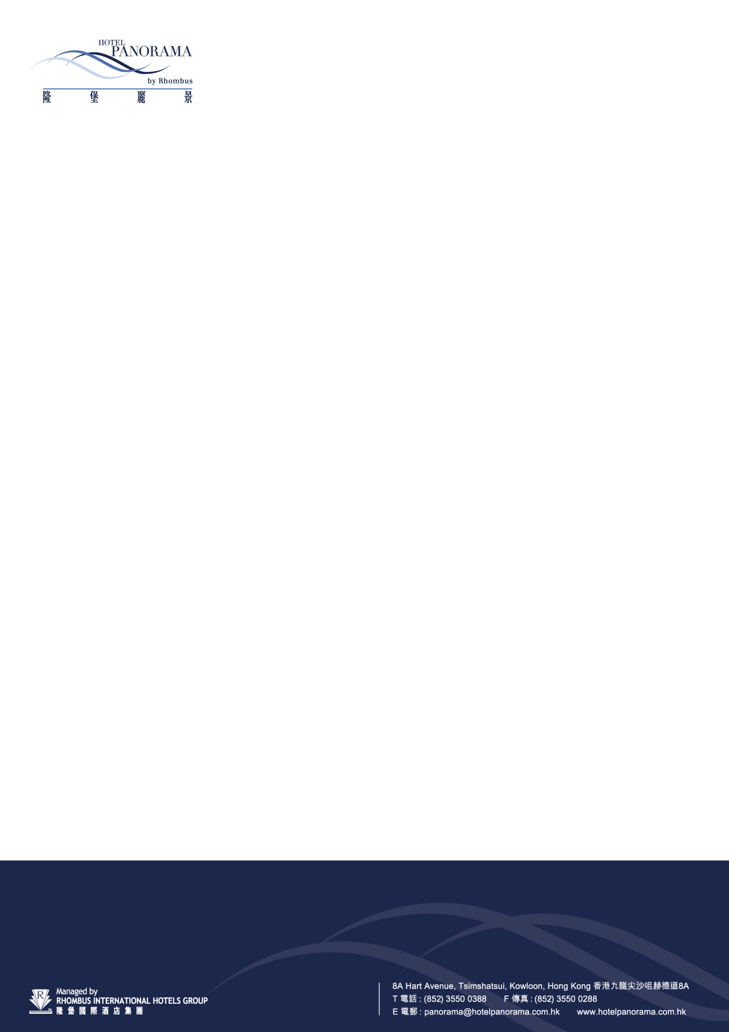

OUHK Int’l Conference on Open and Flexible Education (ICOFE2015) on 15-18 Jul 2015
To: Mr Kim Chan
Assistant Sales Manager
Hotel Panorama by Rhombus
8A Hart Avenue, Tsimshatsui, Kowloon, Hong Kong
Phone: (852) 3550 0688 Fax: (852) 3550 0699
E-mail: kim_chan@rhombusinternational.com
GUEST DETAILS:
Last Name (Mr/Ms/Mrs/Prof./Dr.): |  |  |  |  |  |  | First Name:
Arrival Date:  Departure Date: |  |  |  |  |  |  | Flight:  Flight: |  |  | Time:  Time:
Telephone: |  |  |  |  |  |  |  | Fax:
Email :
PLEASE RESERVE: (Please tick the appropriate box)
Deluxe Silver Room (with twin beds / double bed) |  |  |  |  | at  HK$935 (Free Wi-Fi)  at  HK$1045 (Free Buffet Breakfast for 1 pax and Wi-Fi)  at  HK$1100 (Free Buffet Breakfast for 2 pax and Wi-Fi)
* Above rates are inclusive of a 10% service charge per room per night.
Special Request:
- Extra Breakfast cost $110 net per person per day
- Shuttle Bus Services (Hotel to / From Airport) is available at HK$140 net per seat per single journey with two standard-size baggage.
RESERVATIONS GUARANTEE:
Credit Card with expiry date is required at the time of booking.
Credit Card details:
□ American Express |  |  | □ Diners Club |  |  | □ Mastercard |  |  | □ Visa |  | □ JCB
Card Holder:  Card No: |  |  |  | Expiry Date:  Signature:
TERMS & CONDITIONS:
- All reservations are subject to hotel availability upon confirmation.
- Extension of stay will be subject to availability and at the prevailing rates.
- For any cancellation or amendment made less than 48 hours prior to arrival or no-show for guaranteed reservations, full penalty will be applied
- Check-in time is after 2:00 pm. Check-out time is before 12:00 noon.
- All expenses will be on guests’ own account.
For hotel use: | Confirmation number: |  |  |  |  | Confirmed by: |  |  |  | Date:

